5G Global Device RequirementS and Architectures

A GTI White Paper

march, 2020

Version 0.0

Contents
List of Figures 2
List of Tables 2
1 Executive Summary 4
2 Introduction 5
3 GTI MM-MB Device Requirements 5
3.1 LTE/3G/2G Multi-Band Requirements 5
3.1.1 LTE Multi-Band Requirements 5
3.1.2 2G/3G Multi-Band Requirements 5
3.2 5G Multi-Band Requirements 5
3.2.1 Standalone Requirements 5
3.2.2 EN-DC / Multi-Mode Requirements 5
3.3 Voice Support 6
3.3.1 2G / 3G Voice Technology Support 6
3.3.2 4G VOICE TECHNOLOGY SUPPORT (CSFB, VOLTE, SRVCC). 6
3.3.3 5G Voice Technology Support (EPS Fallback, VoNR) 6
3.4 2G / 3G Data Support 6
3.4.1 2G Capabilities 6
3.4.2 3G Capabilities 7
3.5 MIMO Support and Antenna Specifications 7
3.5.1 Antenna Requirements 7
3.5.2 MIMO Configuration 7
3.5.3 Transmission Modes and Channel Estimation Requirements 7
3.6 Device Configuration Requirements to Support Roaming Scenarios 7
3.7 Interoperation Requirements 7
3.7.1 Interoperation Requirements among 2G, 3G and 4G 8
3.7.2 Interoperation Requirements between 4G and 5G 8
3.7.3 Interoperation Requirements between SA and NSA 8
3.8 The co-existence requirements between WiFi and 5G 8
3.8.1 Co-existence Requirements between n40/n41 and WiFi 2.4GHz 8
3.8.2 Co-existence Requirements between n79 and WiFi 5GHz 8
3.9 The SRS requirements 8
3.10 The OTA requirements 8
4 Product Requirements 8
4.1 Display Requirements 8
4.2 Battery Requirements 9
4.3 Camera Requirements 9
5 Testing Requirements 9
5.1 3GPP Spec Conformance requirements 9
5.2 Regulatory Requirements 10
5.3 National / Operator Specific Requirements 10
6 Device Architecure Recomendations 10
6.1 Multi-Mode Multi-Band Device Challenges 10
6.2 Device Architectures 10
6.2.1 Global Device Architectures for SMARTPHONES 10
6.2.2 DATA ONLY Device Architectures 10
6.2.2.1 Multi-Mode MUlti-Band Architecture for Mobile Hotspots 11
6.2.2.2 Multi-Mode Multi-Band Architecture for Tablets 11
7 Conclusion 11
8 References 12
9 Appendix - I 12

List of Figures

No table of figures entries found.

List of Tables

No table of figures entries found.

DISCLAIMER
Use of this document is subject to the disclaimers and limitations described below. Use of this document constitutes acceptance of the following terms and conditions:
THIS DOCUMENT IS PROVIDED “AS IS” AND WITHOUT WARRANTY OF ANY KIND. TO THE GREATEST EXTENT PERMITTED BY LAW, THE SPONSORING COMPANIES DISCLAIM ALL EXPRESS, IMPLIED AND STATUTORY WARRANTIES, INCLUDING, WITHOUT LIMITATION, THE IMPLIED WARRANTIES OF TITLE, NONINFRINGEMENT, MERCHANTABILITY AND FITNESS FOR A PARTICULAR PURPOSE. THE SPONSORING COMPANIES DO NOT WARRANT THAT THIS DOCUMENT IS COMPLETE OR WITHOUT ERROR AND DISCLAIMS ANY WARRANTIES TO THE CONTRARY.
Any products or services provided using technology described in or implemented in connection with this document might be subject to various regulatory controls under the laws and regulations of various governments worldwide. The user is solely responsible for the compliance of its products and/or services with any such laws and regulations and for obtaining any and all required authorizations, permits, or licenses for its products and/or services as a result of such regulations within the applicable jurisdiction.
NOTHING IN THIS DOCUMENT CREATES ANY WARRANTIES WHATSOEVER REGARDING THE APPLICABILITY OR NON-APPLICABILITY OF ANY SUCH LAWS OR REGULATIONS OR THE SUITABILITY OR NON-SUITABILITY OF ANY SUCH PRODUCT OR SERVICE FOR USE IN ANY JURISDICTION.
NOTHING IN THIS DOCUMENT CREATES ANY WARRANTIES WHATSOEVER REGARDING THE SUITABILITY OR NON-SUITABILITY OF A PRODUCT OR A SERVICE FOR CERTIFICATION UNDER ANY CERTIFICATION PROGRAM OR ANY THIRD PARTY.

Executive Summary

.

Introduction

GTI MM-MB Device Requirements

.

LTE/3G/2G Multi-Band Requirements

3.1.1 LTE Multi-Band Requirements

3.1.2 2G/3G Multi-Band Requirements

5G Multi-Band Requirements

Standalone Requirements

EN-DC / Multi-Mode Requirements

.

Voice Support
The voice services provided over Public Land Mobile Network (PLMN) are featured with global interoperability and accessibility across different mobile networks radiating signals using different radio technologies, different fixed networks, employing either IP based packet switch technology or circuit switched technology. Subscribers enjoy unified user interfaces/habits to make call from the terminal devices and obtain the similar user experience worldwide.
Apparently, the voice service is still the most important service/application provided by MNO to attract subscribers. The voice service possesses a special role in 5G network deployment. Providing satisfied voice service in 5G era is critical to 5G targeted network strategy.
Such worldwide usable voice services over one single subscription is achieved not only because the interconnected telecommunication infrastructures, well established technical standards and well-coordinated roaming agreements among MNOs, but also highly rely on multimode-multiband terminal devices which play extremely important role to enable the global interoperated voice services.
For 5G MMMB devices, depending on the RAT/CN technology the device standby and the infrastructure capability, there would be different voice solutions for the device. At a very high-level, these voice solutions can be divided into two groups.
- Make a voice call over the RAT/CN the MMMB device initially standby.
  - Voice over 2G (GSM)
  - Voice over 3G (TD-SCDMA, WCDMA, CDMA2000)
  - VoLTE over 4G (LTE)
  - VoNR over 5G (NR)
- Make a voice with fallback/handover to another RAT/CN other than it initially standby.
  - CS Fallback
  - EPS Fallback
In the following sub-sections, the possible voice solutions for a MMMB device are described in groups according to the RAT technology the MMMB device initial standby.

2G / 3G Voice Technology Support
5G MMMB devices are capable of supporting several types of RAT/CN technologies.
While network deployment across the world are not in the same pace, in some region there might only the 2G/3G network infrastructure. Thus, 5G NR capable devices would need to rely on 2G/3G networks to get mobile services in these specific regions.
Over 2G/3G, voice is provided in a way of circuit switched voice call (CS Call). Voices frame from the device are routed to MSC and switched/transmitted to the peer via previously set up path as illustrated example in Figure 1.
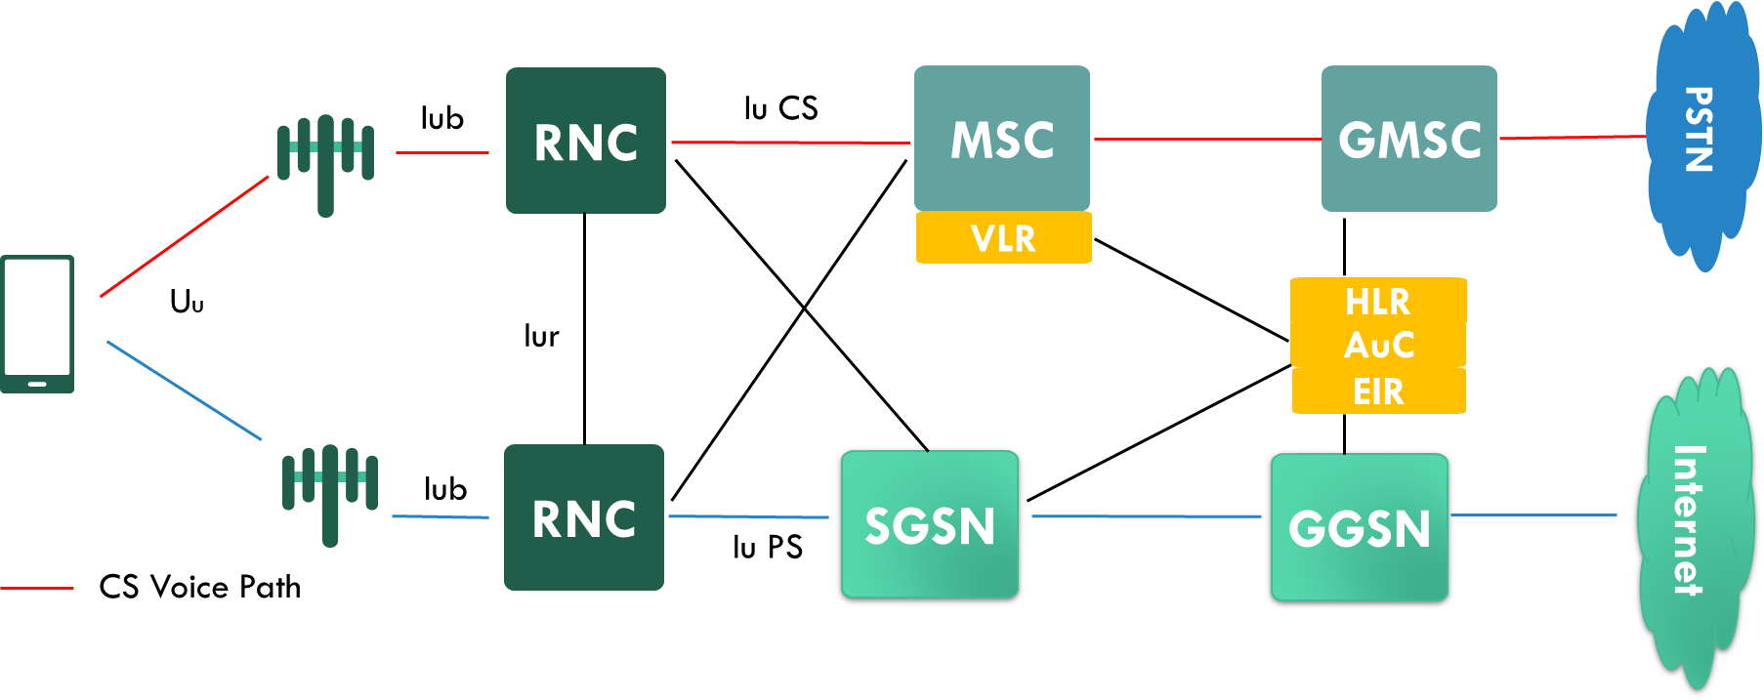
Figure 1 3GPP Release 99 Circuit Switched Voice (CS example)
There are two main 2G RAT-technologies, one is GSM and the other is IS-95/cdma 1x. For 3G, there are three main RAT-technologies TD-SCDMA, WCDMA and CDMA 2000 HRPD. Except for CDMA2000 HRPD, all other 2G/3G RATs support to make the circuit switch (CS) voice call directly. For CDMA 2000 HRPD, usually the device works in hybrid mode, which standby both in cdma 1x and HRPD, and the CS voice call is made over cdma 1x.

4G VOICE TECHNOLOGY SUPPORT (CSFB, VOLTE, SRVCC).
4G is designed as an all-IP network. IMS sub-system is standardized for providing the IP based voice services over 4G.
Depend on IMS sub-system readiness, the optimization of 4G EUTRA/LTE for supporting voice, as well as the additional 4G network features to support voice service, a 5G capable MMMB device which standby on 4G network can adopt following solutions to get voice service.
VoLTE
The Voice over LTE scheme was designed as standardized solution for transferring voice packets over EPC/LTE network. It is based on the IP Multimedia Subsystem (IMS) network which adopt SIP/SDP to set up the call and RTP/RTCP to transfer the voice stream, where the voice service being delivered as data flows within the radio and EPS data bearer.
The aim for VoLTE is to utilize the low latency and QoS features available within LTE to ensure that the voice service offers an improvement over the standards available on the 2G and 3G networks. Introduction of HD voice and video codecs can significantly improve call quality. VoLTE would offer certain advantages over other schemes, such as:
1) Flexible design due to all IP implementation.
2) Call setup time of VoLTE will be shortened if it is well optimized.
3) HD voice and video codecs, if adopted, can improve call/voice quality .
CSFB
CSFB was introduced in 3GPP Rel-8 (TS 23.272) to allow a 4G standby device to return to CS domain for voice services. CSFB specifies the method a UE switches its radio from EUTRAN to other RAT (e.g. GERAN/UTRAN/1xRTT access) that can support CS domain services. With CSFB, the device camps on LTE/EPC and is served by LTE/EPC for data services and when a voice call is triggered, it will fall back to the CS domain and set up the call.
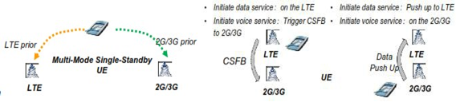
Figure 2 4G CSFB Modes Transition.
CSFB mechanism has little implication on device side, particularly hardware wise, and leads to lower power consumption when compared to some other schemes. However, the call set-up time may be longer than expected in certain cases.
SRVCC
SRVCC offers voice service when the device moves out of the LTE coverage area. Whenever the VoIP subscriber moves out of LTE coverage, SRVCC ensures smooth handoff of voice from the LTE to the CS network, keeping minimum impact on users.
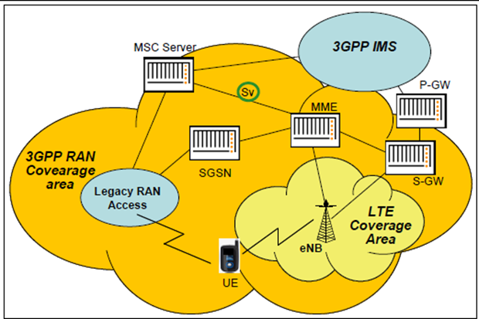
Figure 3 SRVCC network architecture
With SRVCC approach, the SRVCC-capable UE’s engaged in a voice call determines that it is moving away from LTE coverage, it notifies the LTE network. The LTE network determines that the voice call needs to be moved to the legacy circuit domain. It notifies the MSC server of the need to switch the voice call from the packet to the circuit domain and initiates a handover of the LTE voice bearer to the circuit network. The MSC server establishes a bearer path for the mobile in the legacy network and notifies the IMS core that the mobile’s call leg is moving from the packet to the circuit domain. The circuit-packet function in the IMS core then performs the necessary inter-working functions. When the mobile arrives on-channel in the legacy network, it switches its internal voice processing from VoIP to legacy-circuit voice, and the call continues.

5G Voice Technology Support (EPS Fallback, VoNR)
3GPP introduced several network deployment options when start to standardize new radio technology (NR) for 5G, some with a couple of variants which the 3GPP then expanded on when adopting the proposal as part of Release 15. These options provide some kind of flexibility for RAN and CN to evolve separately when MNO migrates their network from 4G to 5G.
Some of the migration options maintain much of the Evolved Packet Core (EPC) infrastructure, allowing to preserve existing IMS core and continue packet voice using VoLTE. And some others enables SBA based 5GC, which can work with legacy IMS with some necessary updates or updates the old IMS interfaces allowing the implementation of core components into the 5G Service Based Architecture (SBA) as studied in 3GPP TR 23.794 and related normative work in 3GPP. Depending on the different network deployment options, there are different voice solutions. This white paper talks about option 3 and option 2.
For option 3, network works in NSA mode with eNB as the master node, UE always camps on LTE and the voice solution is the same as LTE MMMB terminals, aka CSFB or VoLTE/SRVCC that discussed in 3.3.2. For network deployment option 2, there are two solutions available, aka VoNR and EPS fallback.
VoNR
VoNR means to make the voice call over NR-5GC-IMS. As illustrated in Figure 5, the voice packets are carried by 5G NR and 5GC, then go to the IMS subsystem.
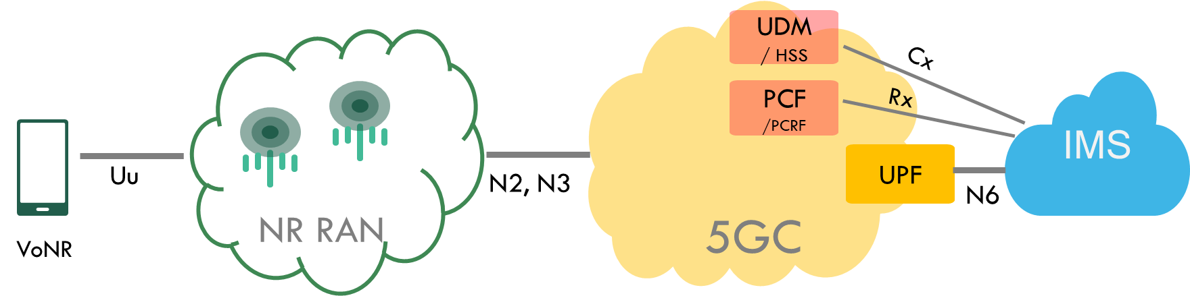
Figure 5 VoNR High-level Architecture
To deploy VoNR, the IMS network need some upgrades, such as adding access type and location information parameters to pertaining interfaces Rx, Sh and etc., or might in future to be updated to eIMS to enable SBI based interfaces for Cx, Rx and etc, thus the IMS sub-system can employ all 5GC functions for voice services.
Network deployment is step by step, NR coverage could not be as good as LTE at the early stage VoNR, inter-system handover from NR to LTE will benefit user experience during network transit from NR to LTE.
EPS Fallback VoLTE
EPS fallback means a 5GC connected device fallback to LTE to rely on VoLTE for voice call. With EPS fallback, UE makes the voice call on ETRAN-EPC-IMS as showed in Figure 4. When a voice call is expected on a 5G SA UE, the UE will make a VoLTE call over EUTRAN-EPC, aka “fallback” to LTE, using VoLTE for voice call. It can be used when VoNR is not ready.
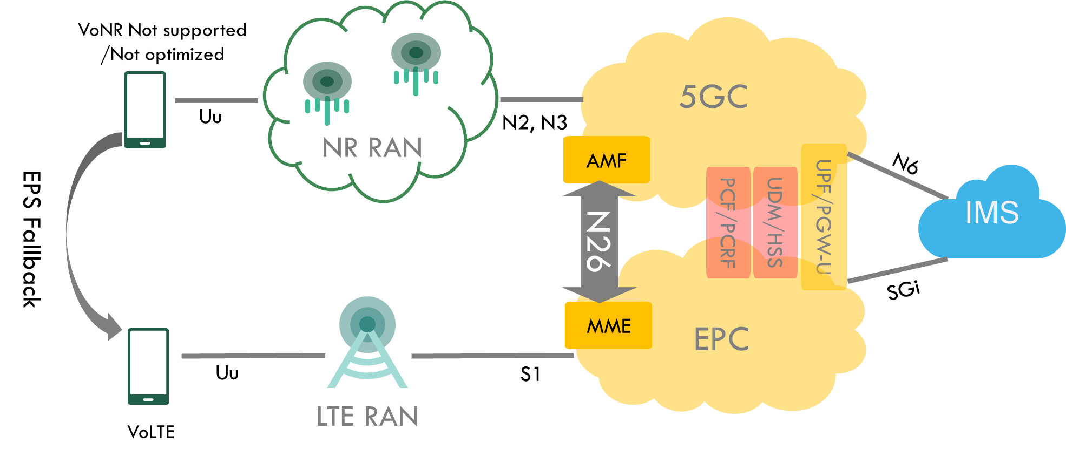
Figure 4 EPS Fallback Architecture

2G / 3G Data Support

2G Capabilities
.

3G Capabilities

.

MIMO Support and Antenna Specifications

Antenna Requirements

MIMO Configuration

.

Transmission Modes and Channel Estimation Requirements

Device Configuration Requirements to Support Roaming Scenarios

.

Interoperation Requirements

3.7.1 Interoperation Requirements among 2G, 3G and 4G

3.7.2 Interoperation Requirements between 4G and 5G

3.7.3 Interoperation Requirements between SA and NSA

The co-existence requirements between WiFi and 5G

3.8.1 Co-existence Requirements between n40/n41 and WiFi 2.4GHz

3.8.2 Co-existence Requirements between n79 and WiFi 5GHz
.

The SRS requirements
.

The OTA requirements
FFS.

Product Requirements

Display Requirements

Battery Requirements

Camera Requirements

Testing Requirements

3GPP Spec Conformance requirements

Regulatory Requirements

National / Operator Specific Requirements

Device Architecure Recomendations

Multi-Mode Multi-Band Device Challenges

Device Architectures

.

Global Device Architectures for SMARTPHONES

.

DATA ONLY Device Architectures
.

Multi-Mode MUlti-Band Architecture for Mobile Hotspots
.

Multi-Mode Multi-Band Architecture for Tablets
.

Conclusion

References
- .

Appendix - I

